Command Pattern and Adapter Pattern

Design Patterns

Christopher Doseck

10/7/2016

Introduction

This assignment is an application that I created to show how the command pattern and the adapter pattern work. In this application I am adapting a class that changes a string into an integer into a class that changes a string into a number. I am also using the command pattern to add that number to a text box, and having it able to be undone and redone.

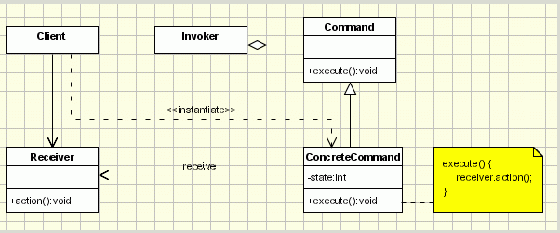The UML Diagram for Command Pattern

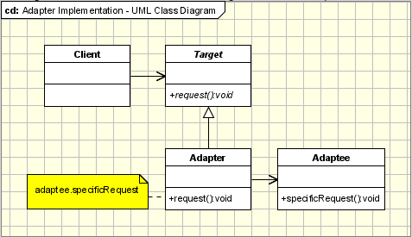The UML Diagram for the command pattern, shown on the right, shows the classes that are needed to have the requirements. I had the command interface as the command interface, the concrete command as the concrete command, and the rich text box as the receiver.

The UML Diagram for Adapter Pattern

The UML Diagram for the adapter pattern, shown on the right, shows the classes that are needed to have the requirements. I used the IStringToInt class as the interface of the adaptee, and StringToInt as the concrete class of the adaptee, which inherits from the IStringToInt. The adapter class is implemented in the NumberAdapter class, inheriting from the StringToNumber class, which adapts the StringToInt class into a StringToNumber interface. The NumberGetter class inherits the StringToNumber class, and has an object of the NumberAdapter class, which makes it the Target class in the diagram. Below is a table with the descriptions of each of the classes.

|  |  |
| --- | --- |
| Form1 | This is the form in which all of the changes are shown via a GUI. |
| Command | This is an interface for the command pattern, used to show what methods are needed. |
| Concrete Command | This class is the class for commands, it has an execute method and an undo method. It uses the NumberGetter class to change a string into a number. |
| IStringToInt | This class is the adaptee interface in the adapter pattern. It is used to sho  w what methods are needed in child classes. |
| StringToInt | This class is the concrete adaptee class. It converts a string into and int through a method with the signature in the IStringToInt interface, which it inherits from. |
| StringToNumber | This is the interface used by the target and the adapter. This is what the IStringToInt and StringToInt are getting adapted into. |
| NumberAdapter | This is a class that inherits from the StringToNumber interface. It contains an object of the StringToInt class, which is stored in an interface of IStringToInt. This is the class that adapts the IStringToInt interface into the StringToNumber interface. This is the adapter class in the UML Diagram. |
| NumberGetter | This class also inherits from the StringToNumber interface. This class sets up the rest of the method that is in StringToNumber. It represents the target class in the UML Diagram. |

Narrative

interface Command

{

void execute();

This is the command interface. It has and execute and undo function.

void undo();

}

This is the concrete command which inherits from the command interface. It stores the number to be added, the previous number, and the previous text from the textbox, as well as the textbox. When the constructor gets called, all of this information is stored. The NumberGetter class is used to turn the string into a number, in this case a double.

public class ConcreteCommand : Command

{

private double addNum;

private double previousNum;

private string previousText;

private RichTextBox textBox;

private NumberGetter numGetter = new NumberGetter();

public ConcreteCommand(RichTextBox tb, string text)

{

this.textBox = tb;

this.previousNum = numGetter.getNumber(tb.Text, tb.Text.Contains("."));

this.addNum = numGetter.getNumber(text, text.Contains("."));

this.previousText = tb.Text;

}

When it is executed, it prints out the previous number from the box added to the number to be added to that number.

When the undo method is executed, it puts the text in the box back to the previous number.

public void execute()

{

textBox.Text = (previousNum + addNum).ToString();

}

public void undo()

{

textBox.Text = previousNum.ToString();

}

}

public interface IStringToInt

{

These are the two interfaces for the adapter pattern, they are described more in the table in the previous section.

int getInt(string text);

}

public interface StringToNumber

{

double getNumber(string text, bool hasPeriod);

}

public class StringToInt : IStringToInt

This is the StringToInt class, as described in the table above. It implements the getInt() method, by parsing the text and returning the int from that.

{

public int getInt(string text)

{

return Int32.Parse(text);

}

}

public class NumberAdapter : StringToNumber

This is the NumberAdapter class which serves as the Adapter Class. It inherits from the StringToNumber interface. It has an object of the StringToInt class, typed as its parent. The NumberAdapter implements the StringToNumber method of getNumber by returning the IStringToInt method of getInt(), if hasPeriod is false.

{

IStringToInt strToInt = new StringToInt();

public double getNumber(string text, bool hasPeriod)

{

if (!hasPeriod)

{

return strToInt.getInt(text);

}

else

return 0;

}

}

public class NumberGetter : StringToNumber

NumberGetter inherits from the StringToNumber interface. It has an object of the NumberAdapter class. When it implements the getNumber() method from StringToNumber, if hasPeriod is true, then it parses for a double and returns that. If it is not true, then it calls the getNumberMethod from the NumberAdapter class.

{

NumberAdapter numAdapt = new NumberAdapter();

public double getNumber(string text, bool hasPeriod)

{

if (hasPeriod) {

return Double.Parse(text);

}

else

{

return numAdapt.getNumber(text, hasPeriod);

}

}

}

These are the stacks of undo commands and redo commands.

public partial class Form1 : Form

{

private Stack<ConcreteCommand> undoCommands = new Stack<ConcreteCommand>();

private Stack<ConcreteCommand> redoCommands = new Stack<ConcreteCommand>();

public Form1()

{

When the form is created, it sets the undo and redo buttons to disabled, and the textbox to have a zero in it.

InitializeComponent();

btnUndo.Enabled = false;

btnRedo.Enabled = false;

tbAllText.Text = 0.ToString();

}

private void btnAddText_Click(object sender, EventArgs e)

{

undoCommands.Push(new ConcreteCommand(tbAllText, tbTextInput.Text));

undoCommands.Peek().execute();

enableButtons();

When the add text button is clicked, it adds a new command with the textbox, and the text to be added to the undo commands and then executes the command. Then it calls the enable buttons method.

When the undo button is clicked, it pops the command off the undo button stack and pushes it onto the redo stack, then calls the undo method. It then calls the enable buttons method.

When the redo button is clicked, it pops off the command from the redo stack and pushes it onto the undo stack. It then calls the enable buttons method.

The enable buttons method checks to see if there are any commands in each stack, if there are, it enables the button for that stack, if not, it disables the button for that stack.

}

private void btnUndo_Click(object sender, EventArgs e)

{

ConcreteCommand command = undoCommands.Pop();

redoCommands.Push(command);

command.undo();

enableButtons();

}

private void btnRedo_Click(object sender, EventArgs e)

{

ConcreteCommand command = redoCommands.Pop();

undoCommands.Push(command);

command.execute();

enableButtons();

}

private void enableButtons()

{

if (undoCommands.Count == 0)

btnUndo.Enabled = false;

else

btnUndo.Enabled = true;

if (redoCommands.Count == 0)

btnRedo.Enabled = false;

else

btnRedo.Enabled = true;

}

}

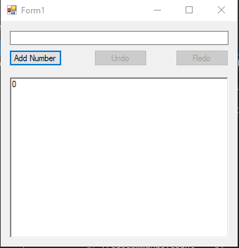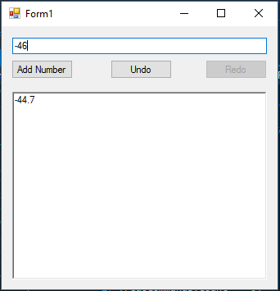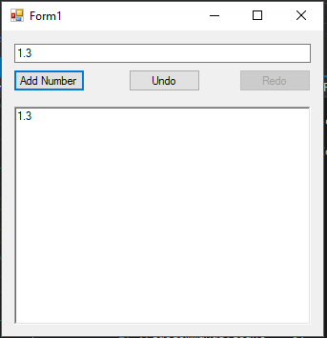

Undo was pressed, redo button has been enabled.

-46 was added.

1.3 was added, undo button has become enabled.

This is the initial setup, notice both buttons are disabled.

Redo pressed, undo button enabled again.

Undo pressed again, undo button disabled because stack is empty.

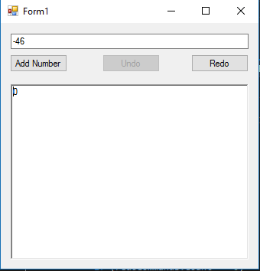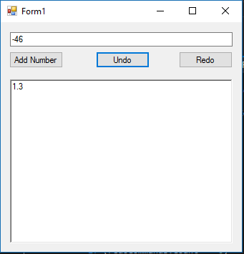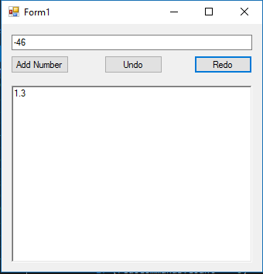

Redo button pressed again, no longer enabled because stack is empty.

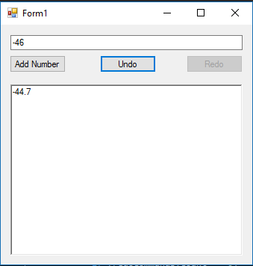

Observations

I really enjoyed doing the command pattern part of this assignment. The command pattern was easy to do, but was extremely useful. I did not like having to do two patterns in one assignment. I thought that it took away from learning each of the patterns some by trying to get them to work together.